**Presentation Policy**

## Purpose

The purpose of this policy is to ensure a consistently high standard of presentation across the whole school which all children and staff recognise, understand and follow.

This policy is to be used in line with the Marking and Feedback Policy and other relevant policies.

## Application

These expectations are intended to apply to the vast majority of children in our school. Occasionally a decision will need to be made to personalise the presentation expectations for a child who has such specific needs that these expectations could be a barrier to their progress (e.g. a child with physical difficulties affecting writing).

## Making it a reality

Staff will ensure that presentation of work is actively taught as it will not ‘just happen’. It should be a focus at the start of each academic year and then be referred to periodically throughout the year.

Where possible, all staff should ensure that presentation is celebrated through:

* Displaying work with a high standard of presentation
* Celebrating work with a high standard of presentation in whole class situations.
* Ensure good presentation is rewarded in line with whole school behaviour policy (praise, Dojo Points, certificates)
* Sharing of good work in whole school assemblies

.

* Handwriting will be taught in line with the handwriting policy on a regular basis. The foci of these lessons will be correct letter formation and continuous cursive handwriting. Children will need to be taught how to write using a continuous cursive style in line with the Handwriting Policy.
* Presentation expectations will be stuck into the front of all maths and English books as well as displayed in classrooms, where teachers will refer to them to remind children of the expectations. See Appendix 1.

General rules

* All drawings and diagrams should be in pencil and completed on plain paper, using a ruler where relevant.
* All dates should be written in full on the left hand side of the page and underlined in pencil in every subject (with the exception of Mathematics and Spelling).
* LOs should be started by the margin and underlined in pencil.
* Felt-tip pens are not used in exercise books.
* Gel pens should not be used in exercise books.
* Coloured pens will only be used for specific reasons by children, e.g. for marking and purple pen for self-correcting and editing.
* Coloured pencils should be used in exercise books.
* One single line is used to cross out mistakes.
* Absolutely no writing on covers or on the inside covers of books.
* No doodling on pages in books or on covers.
* Tippex and corrections pens are not used.

Starting new work

Children should be taught where to begin a new piece of work. As a general rule, children will start a new page when there are only a few lines left; otherwise they rule off and use the same page. Children should also be taught to leave three/four lines if work requires written feedback.

Monitoring

Presentation will be monitored by the Senior Leadership Team on a regular basis through:

* Book Looks
* Learning Walks/Diagnostic Learning Walks/Drop-ins
* Lesson Observations
* Pupil interviews
* Internal/external moderation

## EYFS

Expectations of presentation in Reception will change significantly as the year progresses and the children move towards transition to Year 1. It is expected that the majority of children will be writing some words independently and some children will be writing in sentences in the summer term of Year R.

Dating work

* Work will be dated by an adult.

Writing equipment

* Children will usually write in pencil in books or on paper, depending on the activity
* Whiteboard pens are used on whiteboards and then copied, and highlighters/felt pens/colouring pencils are also used in continuous provision

Staff will encourage

* Correct letter formation and orientation in line with the Handwriting Policy.

.

## Key Stage 1

Equipment

* All work will be written in pencil.
* Only coloured pencils will be used in exercise books. Felt-tip pens will only be used on separate sheets of paper.
* Children will be expected and taught how to use a ruler to draw lines, including underlining, diagrams, labelling and crossing out.

Handwriting

* Staff will emphasise correct letter formation through the regular teaching of handwriting.

Indicating errors

* Children will indicate an error with one neat line through work. **Children will need to be taught how to do this.**

Dating work and Learning Objectives (Los)

Full dates e.g Monday 25th January 2022 will be written/typed in all subjects with the exception of Mathematics and Spelling/Times Tables where the short date may be written (02/03/2019).

Year 1 - Dates and LOs will be typed and underlined on strips for each lesson.

Year 2 - Dates and LOs will be typed and underlined on strips for each lesson. Children will work towards writing their own dates and LOs by the end of Year 2.

Maths Books

* Only pencil to be used apart from purple pen for next steps and editing.
* Children to be taught to use 1 digit per square.

Care of Books

* Children will be taught not to doodle on pages or on the covers of their books.

**Key Stage 2** Equipment

* During Years 3 and 4, it will be the time to transition from pencil to pen. Children need to achieve the right to use pen in their work. Only when teachers are sure that children can write consistently well in pen should a ‘pen licence’ be given. Only appropriate blue ink handwriting pens can be used (except for ‘Black Pen’ published work).
* Only coloured pencils will be used in exercise books. Felt-tip pens will only be used on sheets of paper.
* All maths work will be completed in pencil apart from purple pen for next steps and editing.
* Children will be expected and taught how to use a ruler to draw lines, including drawing margins, underlining, diagrams, labelling and crossing out.
* Children will use guidelines if writing on plain paper.

Handwriting

* Handwriting will be taught according to the Handwriting Policy.
* Handwriting books will be used for this.
* Children to try to write in a straight line.

Indicating errors

* Children will indicate an error with one neat line through work. **Children will need to be reminded how to do this.**
* Tippex or correction fluid is not to be used.

Dating work and Learning Objectives

* Full dates e.g Monday 25th January 2024 will be written/typed in all subjects with the exception of Mathematics and Spelling/Times Tables book where the short date may be written (02/03/2024).
* Date written on left (not in the margin) and underlined with a ruler.
* LOs to be started on the left after the margin and underlined with a ruler.

Maths Books

* Only pencil to be used apart from purple pen for next steps and correcting.
* Children to use 1 digit per square.

Care of Books

* Children will be taught not doodle on pages or on the covers of their books.

**Policy reviewed by All Class Teachers**

**July 2024**

**To be reviewed in 2025**



***KS1 Writing Book Presentation Expectations***

* *Write* ***neatly*** *in pencil*
* *Mistakes should be crossed out neatly using one straight line.*

*For example:*

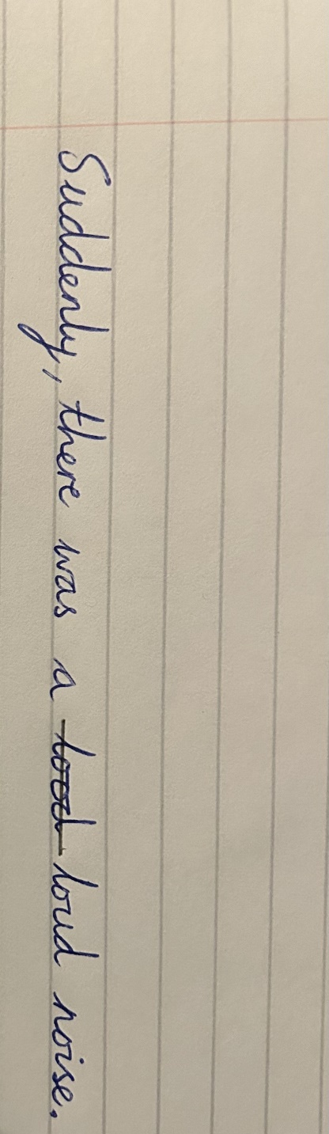

* *Any colouring in should be done using colouring pencils only.*
* *All diagrams, pictures and lines should be drawn in pencil and rulers should be used where necessary.*
* *Use a purple biro for editing, self-corrections and response to feedback.*
* *When sticking in extra sheets, make sure that are straight and not overhanging the edges of the page.*
* *There should be* ***NO*** *doodling on the pages or cover of your book.*



***KS1 Maths Book Presentation Expectations***

* *Draw a margin using a pencil and a ruler on the left-hand side of the page*
* *Write* ***neatly*** *using pencil*
* *Always write 1 digit in each square*

*For example:*

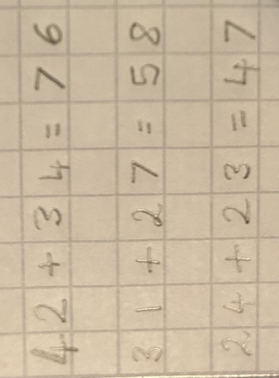

* *Write question numbers using brackets.*

*For example:*

*1)*

*2)*

*3)*

* *Mistakes should be crossed out neatly using one straight line.*
* *Any colouring in should be done using colouring pencils only.*
* *All diagrams, pictures and lines should be drawn in pencil and rulers should be used where necessary.*
* *Use a purple biro for editing, self-corrections and response to feedback.*
* *When sticking in extra sheets, make sure that are straight and not overhanging the edges of the page.*
* *There should be* ***NO*** *doodling on the pages or cover of your book.*



***KS2 Writing Book Presentation Expectations***

* *Write the full date at the top of the page on the left-hand side, underline it with a pencil and ruler.*
* *Write the LO underneath the date, starting at the margin. Underline it with a pencil and a ruler.*

*For example:*

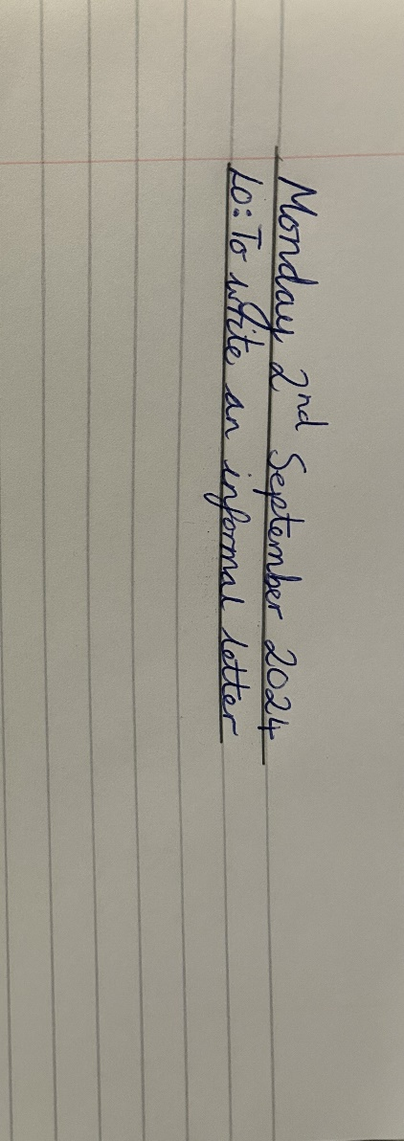

* *Write* ***neatly*** *in pencil or use a blue handwriting pen if you have a pen licence.*
* *Mistakes should be crossed out neatly using one straight line.*

*For example:*

**

* *Any colouring in should be done using colouring pencils only.*
* *All diagrams, pictures and lines should be drawn in pencil and rulers should be used where necessary.*
* *Use a purple biro for editing, self-corrections and response to feedback.*
* *When sticking in extra sheets, make sure that are straight and not overhanging the edges of the page.*
* *There should be* ***NO*** *doodling on the pages or cover of your book.*



***KS2 Maths Book Presentation Expectations***

* *Draw a margin using a pencil and a ruler on the left-hand side of the page*
* *Write the short date in the top left-hand side of the page and underline it using a ruler*
* *Write the LO underneath the date and underline it using a ruler*

*For example:*

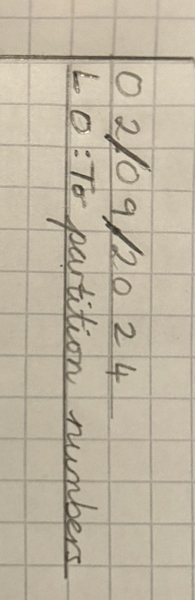

* *Write* ***neatly*** *using pencil*
* *Always write 1 digit in each square*

*For example:*



* *Write question numbers using brackets.*

*For example:*

*1)*

*2)*

*3)*

* *Mistakes should be crossed out neatly using one straight line.*
* *Any colouring in should be done using colouring pencils only.*
* *All diagrams, pictures and lines should be drawn in pencil and rulers should be used where necessary.*
* *Use a purple biro for editing, self-corrections and response to feedback.*
* *When sticking in extra sheets, make sure that are straight and not overhanging the edges of the page.*
* *There should be* ***NO*** *doodling on the pages or cover of your book.*