Eagle Class Challenge Homework Autumn 1 – Amazing Americas
Please note: There is the expectation that homework will be completed each week.
We would like children to complete a Maths and English task each week, which will be set on Education City or MyMaths, or given as a paper-based exercise. There is also an expectation that the children will practise reading, spellings and times tables regularly at home. The weekly tasks will support your child’s learning. Children can also complete other challenge tasks as well throughout the half term.
The deadline for challenge tasks is Tuesday 22nd October 2024 but they can be handed in at any point before this.
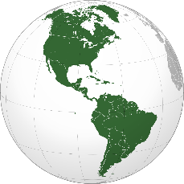 | Regular Weekly Homework: Reading, spelling practice, multiplication practice.  Reminder: Copies of spelling sheets can be found on Dojo and our class web page. Spelling tests will take place every Friday and times tables tests will take place every Thursday. Any reading at home should be recorded in the reading record.  Topic linked homework: choose at least one of these challenges to complete each week. Each task is worth 5 Dojo Points
 | Knowledge and Understanding | Applying and Analysing |  | Creating and Evaluating
Communication and Literacy  (Reading, Writing and Speaking) | EGPS (English, Grammar, Punctuation and Grammar)  Weekly tasks will be set on Education City (www.educationcity.com) or given as a paper-based activity | Reading Activity  Choose a book to read for pleasure and complete a book review. Templates are available if needed or you can create your own format if you would like to. |  | Writing Activity  Based on the Journey, Quest, Return trilogy by Aaron Becker, write your own story based on a journey or a quest.  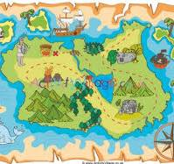
Logical, Reasoning and Mathematical  (Science and Maths) | Maths – Weekly  Weekly tasks will be set on MyMaths (www.mymaths.co.uk) or Education City (www.educationcity.com) or a paper-based activity |  | Science  Our science unit this half term is Living Things and their Habitats. Choose a minibeast and create a 3D model of it and produce a fact file about it.  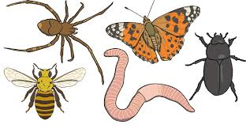
Visual / Spatial / Kinaesthetic  (Creative Arts) | Art  Can you find out about any famous North or South American artists? Can you create a piece of art work based on their style? |  | Geography  In geography we will be learning about The Americas. Can you find out about an animal that is native to North or South America and create a piece of artwork or information report based on that animal? Be creative!
School Value  (Co-operation) | Design a maths themed board game that you could play with a group of people. Write out the game rules and instructions clearly so that it can be played fairly. Can you make the board game for a bonus 10 points?
OWN TASK: Earn up to an additional 10 Dojo Points for a task of your choice related to the topics we are covering in class this term.
In keeping with the school’s value of aspiration, we would like to remind you that we expect homework to be of the highest possible standard and encourage all pupils to give in their homework on time. Remember – you also need to apply our school value of cooperation and strive to achieve as many Dojo Points for your team as possible.

