Year 6 Eagle Class Challenge Homework Spring 1
Please note: There is the expectation that homework will be completed each week.
We would like children to complete a Maths and EGPS task each week – tasks will be set using the platforms Education City and MyMaths. The weekly tasks will support your child’s learning. Should weekly homework tasks not be completed, time will be provided, during lunch breaks, in school for your child to complete them. Children can also complete other challenge tasks as well throughout the half term. The deadline for challenge tasks is Friday 14th February 2025.
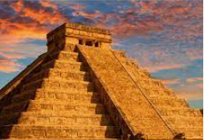 |  | Regular Weekly Homework: Reading, statutory Year 5/6 spellings, multiplication practice.  Reminder: Copies of spelling sheets can be found on our class web page.  Topic linked homework: choose at least one of these challenges to complete each week. You should aim to complete enough activities to earn a minimum of 30 house points. Each task is worth 5 Dojo points.
 |  | Knowledge and Understanding |  | Applying and Analysing |  |  | Creating and Evaluating
Communication and Literacy  (Reading, Writing and Speaking) |  | EGPS (English, Grammar, Punctuation and Grammar)  Weekly tasks will be set on Education City (www.educationcity.com) or sent home as a paper exercise. |  | Reading Activity  Choose a book to read for pleasure and complete a book review. Templates are available if needed or you can create your own format if you would like to  Daily reading is encouraged and reading records should be completed weekly |  |  | Writing Activity  We will be using some Mayan myths as our core texts this half term. Can you plan and write your own myth based on the Mayan beliefs.
Logical, Reasoning and Mathematical  (Science and Maths) |  | Maths – Weekly  Each week (Thursday), an activity will be set on MyMaths (www.mymaths.co.uk) or Education City or sent home as a paper-based activity. This will be related to the work completed in class that week to ensure consolidation of understanding. Please complete the activity set by the following Tuesday. If there are any issues accessing a device to complete these tasks, please do let either Mrs Bunch or Mrs Rope know ASAP. |  |  | Science  In Science, we will be learning about electricity. Can you design an electrical safety poster? | Internet Safety Day 11th February 2025  This year’s Safer Internet Day has a theme around starting conversations about life online. Have a conversation with a trusted adult about your online experiences. Be honest about the games you play and the online chat you get involved with.
Visual / Spatial / Kinaesthetic  (Creative Arts) |  | Art and design  Can you create a piece of art work inspired by Mayan designs?  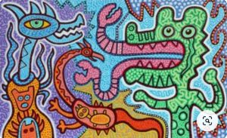 | History  In history we will be learning about the Ancient Maya Civilisation.  Can you write a fact book about the Maya? Include details about where and when the civilisation lived, the daily life and their beliefs, amongst other information.
School Value  (Independence) | Being able to complete tasks independently is important, particularly as you transition to secondary school. Can you write about a task that you have started to complete independently?
OWN TASK: Earn up to an additional 10 house points for a task of your choice related to the topics we are covering in class this term.

In keeping with the school’s value of aspiration, we would like to remind you that we expect homework to be of the highest possible standard and encourage all pupils to give in their homework on time. Remember – you also need to apply our school value of cooperation and strive to achieve as many house points for your team as possible.

