Year 2 Challenge Homework Spring 1 – Woodland Wildlife
Please note: At least one homework should be completed each week in addition to learning spellings, reading and Education city weekly homework. Homework will be set on Tuesdays and will be due on Tuesdays. Any project homework must be completed by 14th February 2025.
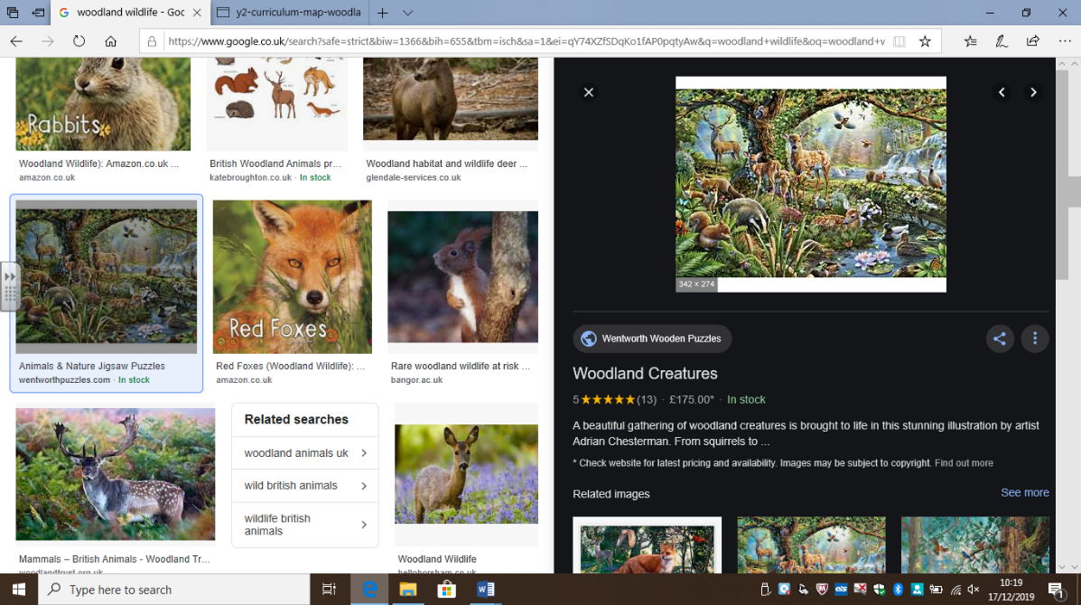 | Regular Weekly Homework: Reading, spellings and Education City.  Reminder: Copies of spelling sheets & times tables can be found on our Class web page and Dojo.  Topic-Linked Homework: Choose at least ONE of these challenges to complete each week. Each Task is worth 5 Dojo points, unless stated otherwise.
 | Knowledge and Understanding | Applying and Analysing | Creating and Evaluating
Communication and Literacy  (Reading, Writing and Speaking) | EGPS (English, Grammar, Punctuation and Grammar)  Weekly tasks will be set on Education City (www.educationcity.com).  Please ask Miss Hemsley for a paper copy if needed. | Reading Activity  Please read regularly at home – both your set reading book and books to read for pleasure.  You could challenge yourself to write a book review – templates are available from Miss Hemsley if you would like one. | Character Description  Pick your favourite character from a book, film or TV show. Write a few paragraphs describing what that character looks like, the clothes they wear, what they like to do etc. Please remember to include adjectives and conjunctions as well as concentrating on capital letters, full stops, your spellings and keeping your handwriting as neat as you can. If you would like an extra challenge you could also think of different and exciting sentence openers.
Logical, Reasoning and Mathematical  (Science and Maths) | Maths Online  Please log on to Education City and complete one set activity each week.  www.educationcity.com  Please ask Miss Hemsley for a paper copy if needed. | Computing Activity  Internet Safety Day is on 11th February and the theme is ‘together for a better internet’.    Have a go at designing an online safety poster for us to display in our classroom. | Life Cycles (Science)  In science we will be learning about the life cycle of different animals.  Can you come up with a creative way of showing the stages of the life cycle of either a butterfly or a frog?  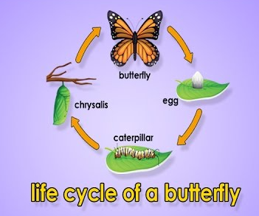
Visual/ Spatial/ Kinesthetic  (Creative Arts) | Art  Pick your favourite woodland animal and draw a picture of it. Try and include as much detail as you can using felt pens, paint or colouring pencils. | Geography  Draw a map of the route between your house and school, adding in any important landmarks or buildings along the way, such as Swanley station, Crockenhill church, village shop, village hall, etc.  You could challenge yourself even further and make you map 3D using paper cut outs.
School Value (Independence) and Growth Mindset | Make your own breakfast or packed lunch and tidy away afterwards. Print photos or send via Dojo of you doing it. You can do this during a weekday or at the weekend. You need to have an adult supervising you, but see if you can do it without them helping you!
OWN TASK: Earn up to an additional 15 Dojo points for a task of your choice related to the topics we are covering in class this term.
In keeping with the school’s value of aspiration, we would like to remind you that we expect homework to be of the highest possible standard and encourage all pupils to give in their homework on time. Remember – you also need to apply our school value of cooperation and strive to achieve as many points for your team as possible.

